

One school.
One student.
One future.
We make a difference.

Student PlayBook
2023-2024

Student Handbook

2023-2024
Pleasant Ridge Montessori 

One school.
One student.
One future.
We make a difference.

5945 Montgomery Rd.

Cincinnati, Ohio 45213

Phone: (513) 363-4400

Fax Number: (513) 363-4420

Vision: PRM is a model for the nation as a premier public urban neighborhood school noted for its diverse and peaceful environment, community involvement, and outstanding student outcomes.

Mission: To offer every neighborhood child a quality Montessori education, collaborating with community partners in a peaceful and environmentally conscious setting that nurtures a love of learning.

Our Character Program
R.O.C.K.S!
Respect, Ownership, Compassion, Kindness, and Safety, Safety, Safety!

This Year’s Theme
Ignite

A Message from the Principal

Greetings PRM Community,
I am excited to welcome you to the 2023-2024 school year. We are a strong school community committed to ensuring that every child has a successful learning experience.

As we continue to grow together, I acknowledge the power and importance of every voice. We want to continue providing multiple communication methods between home and school. All Students will receive a blue Wednesday folder. We will follow our Wednesday folder procedures by ensuring that school information is sent home in the blue folder on Wednesdays. A planner is provided for students in grades 4th-6th as an additional communication tool. The 9-12 team will share requirements for student recording in the planner based on subject and age appropriateness. As a school, we will consistently use the planner to provide additional space for parents and teachers to communicate as needed.
I am so inspired by the work and willingness of our school community to go above and beyond to support our success. I know that we will continue to meet every challenge with the strong spirit of unity and collaboration that makes PRM ROCK! I look forward to partnering with you this year. Happy School Year!

Love,
Principal Simpson

DAILY SCHEDULE
Bus Arrival............................................................................................ 7:30 – 7:40am
Breakfast ............................................................................................. 7:30 – 7:50am
Lunch................................................................................................... 10:00am – 1:05pm
Dismissal .............................................................................................. 2:10pm

STUDENT ENROLLMENT
Students entering our school for the first time must show proof of residency in the Pleasant Ridge Montessori attendance area. Immunization records and birth verification are required if the child is new to Cincinnati Public Schools.

STUDENT WITHDRAWAL
Students withdrawing must have a transfer of records requested by a parent or guardian. Records will be forwarded to the receiving school if financial obligations have been met.

HOURS OF ATTENDANCE
7:40am – 2:10pm

Daily attendance of all students is required by law. Please call the school office at 513-363-4400 before 9:00am when your child is ill. A written note signed by a student’s parent, guardian, or physician is to be given to the teacher when the student returns to school. Acceptable reasons for absences are personal illness, critical illness in the family, quarantine of the home, death of a relative, or observance of religious holidays.

TARDINESS
Classes convene at 7:40am. Late arrivals have a 5-minute grace period to arrive at class before being marked tardy. Instruction begins at 7:40am. If a child arrives after 7:55am, they must report to the office for a tardy slip and then go directly to the classroom. The teacher and/or paraprofessional will keep the tardy slip with the name and arrival time. Tardiness is recorded and reported to the school social worker. The principal and/or school social worker will follow through on excessive absences or tardiness with parents to provide support and/or make juvenile court referrals when necessary.

IMMUNIZATIONS
Certain immunizations are required of all students enrolled in school. Children who do not have the necessary shots by a certain date will be excluded from school attendance. Please visit your local health clinic or family doctor for the appropriate vaccinations. If a child has not been vaccinated and is older than the recommended age, the vaccination is still needed. Your child’s health depends on it!

INSTRUCTIONAL FEES
The Cincinnati Public Schools assess each child with an annual fee to help defray the cost of instructional materials. The fees are assessed on a sliding scale based on family income, grade level, and the number of children per family. CPS does not accept checks for payment. Please send the CPS form and cash (exact change required) or money orders made payable to PRM to your child’s homeroom teacher by August 31st. You may also pay online using Payforit.net.

Non-payment of instructional fees forfeits your child’s involvement in non-instructional field experiences. Unpaid fees accumulate until a student graduates, at which time they must be paid in order for the diploma to be released. If a student transfers to another Cincinnati Public School, the school will hold the student’s transcript until the obligations are paid. Final report cards will be held until fees are paid.

FIELD EXPERIENCES
Field study is an integral part of Montessori education. Field studies are usually scheduled by individual teachers and Teams. Checking backpacks on a daily basis, but especially on Wednesdays, will keep you advised of upcoming outings. Please return signed permission slips and required fees promptly. Opportunities for parents to chaperone are often extended on field experience notifications. Chaperoning a field experience is a wonderful way to share a unique learning experience with your child. All Chaperones must have a volunteer badge at least 2 weeks before the field experience. Please see the Tutor/Volunteer Coordinator to obtain a badge.

YELLOW BUS TRANSPORTATION ELIGIBILITY
A CPS street guide and quadrant information are available online at the CPS website
https://croppermap.com/cincinnati/ All PRM students in grades K–6 who reside more than 1 mile from the school are eligible for yellow bus transportation. Students not using scheduled yellow bus transportation will be removed from the service roster after two weeks of non-use. If you have any questions about transportation, please call the Transportation Office at (513) 363-7433. Preschool students are not eligible for yellow bus transportation.

DISMISSAL/TRANSPORTATION CHANGES
Please notify the office in advance or advise the teacher in writing the morning of that there will be a change in your child’s dismissal/transportation. If no notification is received, your child will follow his/her regular method of getting home each day. According to legal guidelines, we cannot and will not accept verbal notification of changes from a child. Please put such notices in writing to avoid confusion. The note should indicate the exact change of plans.
Note: Temporary yellow bus route changes are NOT available. Yellow bus service route deviations are made on a permanent basis only.

SUDDEN ILLNESS
We will notify the parent or guardian immediately if a child becomes sick at school. We will use your emergency contact information if the parent/guardian cannot be contacted.

Please keep the emergency contact information up to date. We need to be able to contact you if your child ever becomes sick or injured while at school. If a parent is out of town and their child becomes ill, the care provider needs written documentation that they may act on the parent’s behalf.

ARRIVAL PROCEDURES
Morning arrival for all students begins at 7:30am. Students will not be admitted or supervised before 7:30am. All students are expected to be in the school building by 7:40am. If a student arrives after 7:50am, they are considered late.

ARRIVAL BY BUS
If your child rides the bus to school in the morning, they will be dropped off in the front of the building at the curb. One bus will unload at a time. All children will exit the bus orderly and enter the school building through the main doors. The students will be supervised by an adult staff member while outside. Upon entering the building, an adult staff member will direct the students.

ARRIVAL BY CAR
Our car line will enter the driveway and go around the back of the building to the double doors under the covered walkway.
A Paraprofessional will open your door, and your child may exit your car and enter the school building independently. Upon entering, an adult staff member will direct your child. Parents, PLEASE remain in your vehicle at all times.
If you drive your child to school but choose not to use the car line, you are welcome to park across the street in the church parking lot and walk with your child across Montgomery Road to the front door. Please follow these procedures so that we are able to continue to use the church parking lot. You may not drop off students on Montgomery Road right in front of the school. This is a safety hazard and violates traffic laws.
- PRE-SCHOOL PARENTS- If your child is a preschooler, a Paraprofessional will approach your car with a sign-in sheet. Preschool children MUST be signed in by the adult dropping off the child. Signing your Preschool child in and out of school is a state mandate. ALL adults need to be aware of this and have patience while waiting to drop off children in the car line. Please help your child get their seatbelt off and wait for an adult staff member to open your child’s car door.

WALKERS
Your child may enter the school building between 7:30am and 7:40 a.m. Your child will be directed to the proper location to begin their day. Children will not be allowed to enter the building prior to 7:30am. There is no staff available to supervise the children until 7:30am. Please do not drop your children off before 7:30am.

DISMISSAL PROCEDURES
EARLY DISMISSAL
In order to leave during the school day, a student must bring a note to the teacher requesting early dismissal, which must be signed out at the main office. In order to maintain a safe atmosphere, A PHOTO ID WILL BE REQUIRED TO SIGN A STUDENT OUT FROM PRM. If your name is not on the Emergency/Medical contact information listed in PowerSchool, you will NOT be allowed to sign the child out without prior written notice or verification from the parent.

HALF-DAY PRESCHOOL
Dismissal for half-day preschool will begin at 10:30 a.m. and end at 10:40 a.m.
For dismissal, a car line will form in the far right lane on Montgomery Rd, in front of the school. Please remain in your vehicle. A teacher or other staff member will bring your child to your car and open the car door for them. You will be asked to sign your initials next to your child’s name. The adult picking up your child will be responsible for ensuring that your child is secured in their car seat or booster.
It is extremely important that your child is picked up between 10:30 a.m. and 10:40 a.m. We will take any children still waiting at 10:40 a.m. to the office for dismissal. You must park your car and come in to sign your child out.

At the beginning of the school year, you will be asked to give us a list of people that are able to pick up your child. We will not release your child to anyone that does not appear on your list. You must send a written note if you would like someone added.
FULL-DAY PRESCHOOL
Preschool children must be signed out at dismissal time. You may park in the church parking lot across the street or the side parking lot if any spots are available and then walk to the circle to pick up your child.

DISMISSAL K-6
At the beginning of the year, you will receive a form from your classroom teacher asking you to identify your dismissal plans. You must keep this same plan throughout the year. Any proposed changes must be in writing.
CAR
Cars should enter the driveway and circle around to the back of the building. Please do not pass other cars, and stay in the car line. Your child will be brought to the gym beginning at 1:55pm. Staff will come to your car, ask who you are picking up, and then call into the gym for your child to be brought to your car. Please stay in your vehicle.

AFTER-SCHOOL PROGRAMS THAT TRANSPORT STUDENTS
If your child is being picked up by an after-school program that transports students in a van or small bus, they will be directed to pick up your child in the upper parking lot. Your child will be escorted by a staff member and placed in the correct vehicle.

WALKERS
Staff members will bring your child outside with their class beginning at 2:00 p.m. Your child is expected to remain with the staff until you, or the individual you have designated to walk with your child, arrives. If your child is in 3rd grade or higher and has permission to walk home alone, please note that in your beginning-of-the-year information.

PARKING
The church parking lot across the street allows us to use their parking lot. You must pull into a parking spot and walk across the street to pick up your child; no children will be dismissed to walk across the street alone.

LATE PICKUP
School dismisses promptly at 2:10pm. All children must be picked up at this time. There are no staff members available to supervise children after dismissal. No exceptions can be made to this. If you need information regarding available after-school care options, please contact the School Resource Coordinator or visit www.prmrocks.org.

BUS
Kindergarten, ages 6-9 and 9-12, will be escorted to the bus by a staff member. Your child is expected to remain in their bus line until a direction is given to board the bus.

AFTER-SCHOOL ACTIVITIES
If your child is participating in an after-school club or activity here at PRM, this must be communicated in writing to the classroom teacher. At the end of the day, your child will be walked to meet the supervisor of the after-school club at dismissal on the designated days.

CHANGE IN DISMISSAL PLANS
We will not call into the classroom throughout the school day with changes in dismissal procedure due to the number of interruptions to instruction this creates. Classroom teachers are fully engaged in instruction throughout the school day and may not receive email or voice mail messages that are left for them. Consequently, any changes in dismissal/after-school plans for your child must be communicated to the classroom teacher in writing the day before or the morning of the change by 9:00am. If you arrive before dismissal, we ask that you wait outside for the child or in your car until dismissal at 2:10 p.m.

Note: Temporary yellow bus route changes are NOT available. Yellow bus service route deviations are made on a permanent basis only.

BUS SAFETY
A safe, efficient, and equitable transportation service requires teamwork from students, parents, school bus contractors, drivers, teachers, and administrators. In order to provide safe and efficient transportation service, the following plan has been established.

Student behavior that distracts the driver jeopardizes the safety and welfare of all passengers. Therefore, misbehavior on the part of students shall be a sufficient reason for refusing transportation services to those individuals.

Parents should see that their children arrive at the bus stop at least 10 minutes before the scheduled pick-up time to avoid missing the bus. Parents are reminded that the responsibility for supervising their children between home and the bus stop and while waiting for the bus arrival rests with the parent or legal guardian (BP 3541.2).

One of the primary obligations of the school bus driver is to maintain order. A disorderly bus is an unsafe bus. Drivers will issue verbal warnings when appropriate. Continued misconduct on the bus will result in the bus driver filing a Conduct Report for administrative action. A copy of the Conduct Report will be sent home with the student. Remember, the school bus driver is responsible for supervision while students are being transported.

Bus Suspension Reminder Chart
- Referral #1 - Warning and written conduct report sent to parent
- Referral #2 - Warning and written conduct report sent to parent/student conference
- Referral #3 - Removal from the bus for 3 days
- Referral #4 - Removal from the bus for 5 days
- Referral #5 - Removal from the bus for 10 days
- Referral #6 - Removal from the bus for the remainder of the school year

A student may be suspended from the bus immediately by the administrator for any violation that jeopardizes the safety of anyone on the bus. Violating the District Code of Conduct while riding is also cause for suspension/expulsion from school. The school bus driver cannot suspend a student from the bus.

If incidents involve the police, either to remove a student from a bus or to restore order, the following procedure will be applied: Students will be suspended immediately from future bus service pending a conference to be held at the school that includes all students involved in the bus incident, their parents, the school administrator, and a representative from the bus vendor.

BIKE, SKATEBOARD, SCOOTER ETC.

Cincinnati Municipal Code
Sec. 506-5. Bicycles, Operation by Minors.
Minors 15 years of age or less may be permitted to ride bicycles on sidewalks where the buildings do not have the paved portion of the sidewalk, provided that, when approaching a pedestrian or other person lawfully using the sidewalk, any such minor riding on the sidewalk shall give audible warning by means of a bell or horn and shall yield the use of the sidewalk to such pedestrian or other persons dismounting if necessary to do so.

Sec. 505-13. Protective Equipment, Bicycles, Scooters, Skateboards, Roller Skates, and In-Line Skates.
- No person 15 years of age and under shall operate a bicycle, skateboard, or scooter or ride as a passenger on such device, or wear roller skates or in-line skates, within the city of Cincinnati on any public or non-residential property, unless such person is wearing a protective helmet on his or her head, with the chin strap fastened under the chin. Such helmets shall be fitted to the size of the operator and shall meet or exceed the standards set by ANSI (American National Standards Institute), CPSC (Consumer Product Safety Commission), or SNELL (Snell Memorial Foundation). This ordinance shall not apply to any person riding a bicycle, skateboard or scooter as the operator or passenger, or wearing roller skates or in-line skates on any property which is a single-family residence.
- No person who is 15 years of age and under shall violate Section 505-13B.

- The penalty for violating this ordinance shall be as follows:
  - First offense: written warning.

  - Second offense: written warning and the juvenile shall view a safety video within 45 days. Failure to view the video within 45 days shall result in a minor misdemeanor citation.

  - Third and all subsequent offenses: minor misdemeanor. If aggravating circumstances are present, such as a traffic accident or a near accident, or there are accompanying criminal or traffic charges against the minor, the officer shall issue a citation rather than a warning.

For purposes of this Section, "bicycle" shall have the same meaning as defined in Section 501-1-B.

MONTESSORI STUDENT RIGHTS AND RESPONSIBILITIES
Students are the center of our mission; they are the reason parents and educators collaborate to give the best Montessori education available. Students are powerful individuals who largely control their educational process through the attitudes they bring and the decisions they make. It is important that parents/families prepare their children for success by instilling a positive attitude toward learning. The school is joyful when students are excited about learning and succeed in their academic pursuits.
We want to facilitate this joy and collaborate with each of you to provide an excellent education using the Montessori Method.

- Montessori students have the right to exercise their “student power” by working hard to maintain a positive attitude, make proactive decisions, and be responsible learners.

- Montessori students have the right to follow the schoolwide expectations.

- Montessori students have the right to follow the classroom expectations.

- Montessori students have the right to honor their responsibilities.

- Montessori students value friendliness, openness, and helpfulness to each other. These values contribute to a harmonious classroom community where students treat their materials and classmates with respect.

- Montessori students strive for independence. Making good use of class time by completing assignments and participating in group work is the first step in this responsibility.

- Montessori students learn responsibility. Completing homework assignments and arriving at school on time are ways in which students demonstrate their drive toward responsibility.

- Montessori students have the responsibility to be respectful, responsible, and problem-solver.

- Montessori students are responsible for coming to school in the required uniform beginning on the first day.

Homework policy
Students should be given homework daily or weekly (Weekends may be excluded).
Homework should provide practice and/or reinforcement of concepts presented in class. New concepts should not be sent home for homework. Weekly math and reading logs are available for grades 2-6.

Homework Guidelines:
Ages | Range of Minutes daily | Days per week
3-6 | 10-15 | 4
6-9 | 10-45 | 4
9-12 | 40-90 | 4

SCHOOL EXPECTATIONS
Location | Being Respectful | Being Responsible | Being a Problem-Solver
Classroom | - Be kind to adults and classmates  - Raise your hand to talk  - Treat others how you want to be treated!  - Model safe and appropriate behavior | - Keep our community clean and safe  - Take care of classroom materials/supplies  - Arrive on time and in uniform  - Follow adult directions  - Wear your mask (when required) | - Ask questions to understand  - Help others if they have questions  - Be a positive team player  - Always do your best!
Hallways | - Voices off in the hallway  - Be kind to others  - Follow adult directions  - Be aware of personal space | - Stay with your class at all times  - Walk in a straight, quiet single file line  - Keep hands to yourself: do not touch classmates or art on the walls  - Wear your mask (when required) | - Ask an adult for help if you are lost  - Make sure shoes are tied  - Keep eyes forward  - Walk with hands at your sides
Restrooms | - Give people privacy  - Use silent or whisper voices  - Wait your turn. | - Clean up after yourself and others  - Get in and get out, be efficient  - Use only what you need | - Report any problems to an adult  - Wash your hands (20 Seconds)  - Turn water off after use
Cafeteria | - Wait your turn  - Leave your area clean for the next person  - Use inside voices  - Keep your hands and food to yourself | - Place your waste in the correct trash can  - Follow adult directions  - Wear your mask (when required) | - Ask a friend first if you need help  - Report any messes to an adult
Outside | - Take turns  - Demonstrate good sportsmanship and use kind words  - Be mindful of personal space. | - Stop when you hear the whistle blow  - Line up in ABC order when called  - Use equipment properly  - Stay in designated areas  - Wear your mask (when required) | - Tell an adult if there is a problem  - If you see a car, move to the sidewalk or mulch area
Office | - Use kind words and tone  - Wait patiently for you turn  - Voices off while waiting your turn | - Present your hall pass  - Follow adult directions  - Stay seated while waiting  - Wear your mask (when required) | - Keep your body calm and use items gently  - Keep your belongings with you
School Events | - Hands on bodies to yourself  - Follow all adult directions  - Model safe and appropriate behavior | - Enter and exit quietly and calmly  - Stay seated until dismissed  - Stay with your class  - Wear your mask (when required) | - Ignore side comments  - Raise your hand for a teacher if you need help  - Silent reminders for friends
Bus | - Use inside voices  - Be mindful of your own space  - Use kind words  - Touch only your belongings | - Hands and bodies to yourself.  - Think before you act  - Follow all adult directions the first time given  - Walk to and from the bus  - Wear your mask (when required) | - Stay in assigned seats: seat on seat, back on back, feet on floor  - Keep your body and property inside the bus  - Keep aisle clear
Technology | - Be considerate of the privacy of others  - Use kind, positive words | - Be cautious when posting pictures or information online!  - Only use teacher-approved websites  - Wear your mask (when required) | - Report inappropriate and suspicious behavior to an adult  - Say Something to an adult if you see bullying online
Car Line | - Voices Off  - Listen to adults  - Follow Directions | - Stay in assigned area  - Listen for your name  - Wear your mask (when required) | - Help neighbor if they missed their name

UNIFORM POLICY/DRESS CODE
Student dress should be clean, neat and appropriate for learning and not a distraction to education. Uniforms are required for students in grades K-6:
 | Girls | Boys
Tops | Solid color polo shirt or button-down shirt/blouse with a collar  Solid color sweater, fleece pullover or unhooded sweatshirt may be worn  No Labels over 1-inch | Solid color polo shirt or button-down shirt/blouse with a collar  Solid color sweater, fleece pullover or unhooded sweatshirt may be worn  No Labels over an inch
Bottoms | Solid grey, khaki or navy blue slacks, (pants are worn on the waist, use a belt as needed skorts, jumpers, capris)  or  Bermuda length shorts (no shorter than 3 inches above the knee)  No joggers  No sweatpants | Solid grey, khaki or navy blue slacks (pants are worn on the waist, use a belt as needed)  or  Bermuda length shorts(no shorter than 3 inches above the knee)  No joggers  No sweatpants
Shoes | Shoes with a rubber bottom are recommended for school.  No open-back or open-toed shoes (no flip flops or Crocs)
Head | Hoods, hats, do-rags, and bandannas are NOT permitted
Coats | The rooms can be cool at times; however,  coats will NOT be permitted to be worn in the classrooms.

- All faculty/staff will monitor for compliance with the uniform policy.
- Teachers or Paraprofessionals will call the parents of students not in uniform.
- Paraprofessionals will walk students to the office if they are not in uniform to pick out a uniform that is appropriately sized from the Principal’s uniform closet.

Please see the attached sheet with examples of what is and is not allowed but be sure to carefully read the description above with more detail.

Uniform Appropriate | Not Uniform appropriate
  Solid colored slacks    Solid colored skorts, skirts, and jumpers - with or without leggings    Solid colored polo shirt - short or long-sleeve    Solid colored Bermuda length shorts | 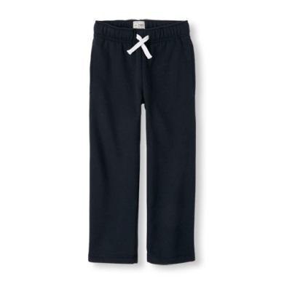  NO SWEATPANTS    NO LEGGINGS BY THEMSELVES    NO HOODED SWEATSHIRTS OR LOGOS LARGER THAN 1”    NO JEANS
ZERO-Tolerance Uniform Policy
Students wearing apparel that does not comply with the policy will be subject to the following procedures:
- First Offense - Students will go to the office to select a uniform from the Principal’s uniform closet with the classroom Paraprofessional. The uniform must be returned at the end of the day, and the student will be given back their clothing. A call will be placed to the parent or guardian, and a note will go home reminding the student of the uniform policy.
- Second Offense - Students will go to the office to select a uniform from the Principal’s uniform closet with the Paraprofessional. The student will return the uniform at the end of the day, and the student will be given back their clothing. A call will be placed to the parent or guardian, and a phone conference will be required.
- Third Offense - Students will go to the office to select a uniform from the Principal’s uniform closet with the Paraprofessional. The student will return the uniform at the end of the day, and the student will be given back their clothing. A call will be placed to the parent or guardian, a parent conference will be required, and a consequence will be given at the discretion of the principal.
CARE OF TEXTBOOKS, LIBRARY BOOKS, AND TECHNOLOGY
Students and parents are responsible for all textbooks and library books issued during the school year. If books are lost, the full replacement cost will be charged. A fine will be charged for a damaged book. Students are also responsible for carrying their district-assigned technology devices from home to school. If there are issues with technology, students and families are encouraged to contact the Family Technology Support Center. They can also drop off their CPS-issued device in the front office and swap it out for another. If technology is purposefully damaged, the student will be fined the cost of fixing the piece of technology.
For CPS students and their families, help is a phone call away by dialing the Family Technology Support Center at
(513) 363-0688 or emailing fts@cpsboe.k12.oh.us. Tech support is available in English and Spanish from 8 a.m.–6 p.m., Monday through Friday, when school is in session.
BACKPACKS/BOOK-BAGS
Students need backpacks/book bags to carry books and school supplies between home and school. Being organized is an important part of being prepared for learning.

Helpful tips:
- Put school supplies, lunch money, and completed homework in your child’s backpack every evening. Then place the bag by the door so you’re ready to go in the morning.
- Put your child’s name on the backpack in a visible place.
- Please check your child’s backpack every evening. Remember, written communication is the primary contact method between the school and parents.
- Check daily for the following:
  - Graded papers
  - Homework assignments
  - Field trip notifications/permission slips
  - Calendar changes
  - Updates
  - Teacher Newsletters (Teacher discretion)
  - Principal Newsletter (first Wednesday of each month)

SCHOOL SUPPLIES
Every teacher sends home a school supply list. Part of being prepared for class every day involves having all the teachers' requested supplies. Please ensure your child has everything he or she needs to succeed in school. Please check with the teacher if you are unsure of your child’s school supply needs.

PERSONAL ITEMS
Students should not bring personal items such as the following:
- Toys
- Balls of any kind (recess equipment is provided by the school)
- Games
- Audio/visual equipment
- Video games
- Radios
- CD players
- iPods and other MP3 Players
- Expensive jewelry
- Apple watches and other smartwatches that may act as communication devices
These items are a distraction to the learning environment. If a staff member sees a student with such items at PRM, the item(s) will be taken and held in the office until retrieved by the parent/guardian.

The PRM staff will not be held responsible for items lost or stolen, and there will be no investigation of prohibited personal items reported lost or stolen.

CELL PHONE POLICY
Pleasant Ridge Montessori School and staff are not responsible for lost or stolen cell phones. Consequently, we will not investigate lost or stolen cell phones.

The use of cell phones during school hours is prohibited.
- Cell phones may not be visible during school hours.
- Students must turn cell phones off during the entire school day, including lunchtime and any mandatory after-school intervention.
- Cell phones that are left on will be confiscated and can be picked up after school by a parent or guardian in the main office.

MEDICATION
The school staff cannot administer medicine or pain relievers of any type without the parent and physician's expressed written consent. Students who need to take prescribed medication must have a “Dispensing Medication Form” that has been signed by both the physician and parent on file in the office before the medication can be brought to school. Medication to be administered at school must remain in the office.

COUNSELING SERVICES
Counseling services are provided for our students with our partner Best Point (Children’s Home) and with the assistance of our School Resource Coordinator and School Psychologist. Parent/Guardian permission is required for students to work with the counselor. Talk with your teacher if you have concerns and would like to refer your child to counseling services.

BIRTHDAY CELEBRATIONS
Parents who wish to send treats to share with their child’s classmates should follow the homeroom teacher’s policy concerning the distribution of treats.
Please be mindful of our students’ feelings when delivering invitations to birthday parties. Invitations should not be delivered at school unless every child in the class is invited to the party.

GENERAL INFORMATION

INCLEMENT WEATHER
“Snow days” (no-school days) are inconvenient for many parents, so the superintendent closes or delays schools only when absolutely necessary. The superintendent and her team aim to make decisions about school closings or delays prior to 5 a.m. so that the website and the news media can relay the information to parents in time for child-care decisions to be made. Please have a plan in place for such closures, as predictability is limited.
TWO-HOUR DELAY
- Yellow buses (which transport elementary school students only) will pick up students at morning bus stops two hours later than normal.
- Students who are driven to school by parents should try to arrive at schools as near to normal times as possible. Walkers should arrive as near to normal times as possible, weather permitting. School staff will supervise students in the buildings at regularly scheduled start times. No new material will be covered; teachers will use this opportunity for review and enrichment.
- No preschool bus service will be available.
- Afternoon dismissal will occur at each elementary school's normal time.

BREAKFAST AND LUNCH PROGRAMS
- Free to all students.
- Breakfast will be served from 7:30-7:50am.
- Breakfast will be available at each entrance via the breakfast kiosk. All students will eat breakfast in their homerooms.
EMERGENCY DRILLS
The safety of all students is a primary concern at PRM. Consequently, PRM students participate in numerous drills throughout the school year to prepare for emergencies.

- Fire drills require students to exit the building by walking quickly and silently in single-file lines. It is important that students remain calm and walk in order to prevent the tripping hazards that can occur with panic and running. Silence is required so students can hear instructions clearly. When the drill is over, students are to re-enter the building in the same manner.
- Tornado drills require students to travel quickly and silently to the ground level of the school building and then kneel on the floor with heads touching the wall and hands covering their heads. Students remain in this position until staff members tell them that the drill has ended.

- Shelter-in-place requires that all students and staff members move to the highest floor in the building until the outside emergency has been resolved. Parents, please explain to your children the need to be prepared in an emergency and encourage them to follow drill procedures with full cooperation.

- Lockdown drills seal a school, preventing anyone from entering or leaving the building during an emergency situation. During a lockdown, students usually are kept inside classrooms and out of hallways and common areas. Main and classroom doors are locked, and windows are secured.

- Searches The Cincinnati Public School District is committed to providing a quality education for students in an environment conducive to learning and protecting the health and safety of the entire school community. Since 1994, when the Cincinnati Board of Education approved a policy on using security devices, including metal detectors, the district has found that searches have drastically reduced the number of weapons incidents in our schools.
Searches may only be conducted under two conditions to protect your child's rights:
- Random or Systematic Searches. These searches are conducted in a random and systematic manner, without specific suspicion, to keep students from bringing contraband or weapons to school. The search method is predetermined and random in nature, prohibiting race and gender bias. Once the random method is selected and the search is begun, it is not changed unless reasonable suspicion occurs. If reasonable suspicion is aroused, then the action listed below under “Reasonable Suspicion” will be taken. Some examples of random search methods include locker searches, students caught in a hall sweep, selected classrooms, and vehicles in the parking lot.
- Reasonable Suspicion. This type of search is conducted when there is reasonable evidence pointing to a specific individual(s) who may be in violation of criminal statutes or school rules. The following types of searches are examples of Reasonable Suspicion Searches: lockers, personal; limited clothing; pat down; request to empty pockets, purses, backpacks, boxes, etc.; or vehicle.
School administrators and security personnel are fully trained in properly using metal detection equipment. All searches are conducted within the guidelines of the law and the Board of Education’s policy 5144.1, “Rights of Privacy.”
If students fail to cooperate with a search, they will be subject to the appropriate disciplinary action.

RECESS
Unless the weather is extremely inclement, we go out to play (32° or higher). Therefore, students should come to school wearing proper clothing. This includes a coat, hat, gloves, scarf, and boots in the winter. Adult supervision is present at all times. Students are expected to:
  - Participate in positive play activities.
  - Report problems that occur to the adult on duty.
  - Remain outside until the class is brought in by the teacher.
  - Line up as directed and be ready for the teacher to return them to the building.
**On inclement weather days, teachers will have recess indoors.
Playground Equipment Bin: Procedures
- These materials are for use by PRM students
- First whistle: Freeze; after freezing, those with equipment will return balls, hula hoops, jump rope, chalk, etc., to bins
- Second whistle: Line up
- One adult stays at the bin to monitor (make sure there is a designated backup person)
- Lock the bin at the end of the day (last recess of the day)
**Pumps for balls can be found in Coach Jerry's office
**Only adult staff have the lock code

HOME-SCHOOL COMMUNICATION
We want to continue providing multiple communication methods between home and school. All Students will receive a blue Wednesday folder. We will follow our Wednesday folder procedures by ensuring that school information is sent home in the blue folder on Wednesdays. A planner is provided for students in grades 4th-6th as an additional communication tool. The 9-12 team will share requirements for student recording in the planner based on subject and age appropriateness. As a school, we will consistently use the planner to provide additional space for parents and teachers to communicate as needed.

A monthly newsletter from the principal will be sent to the email on file in PowerSchool, along with robocalls as necessary with reminders for school events or announcements by the principal. Teachers may also send newsletters or use group messaging platforms at their discretion to communicate classroom updates and information. The PTO and School Resource Coordinator will publish monthly calendars and contribute to the monthly newsletters sent by the principal. The School Resource Coordinator will also provide a monthly progress report.

Many publications and updates are published on the Internet. To access this information, log onto the web page http://pridge.cps-k12.org/. Look for the link to www.prmrocks.org to learn more about PRM.
LOST AND FOUND
Lost articles will be placed in a basket or rack in the front foyer near the office. Please check there for your child’s missing items. Please put your child’s name and room number on all of his/her belongings. Please check monthly at the PTO meetings for lost articles. Unclaimed items will be donated following each PTO meeting.

PARENTS/GUARDIANS
GUIDELINES FOR CALLING A STAFF MEMBER
When calling a staff member, be sure to leave your name, your child’s name, the reason for your call, and your phone number(s) with the person taking the message. A message will be placed in the staff member’s mailbox so that your call can be returned after school. Please refer to the staff directory for your teacher’s classroom phone number if you want to leave a message on their voicemail.
Note: Staff members frequently have meetings after school and may not receive messages until the following day, but your call will be returned within 48 hours.

VISITING SCHOOL
All parents and guests are to report to the main office. Should you desire to visit a classroom, please contact the teacher ahead of time to schedule a mutually convenient time. You are always welcome. You must sign in using the Lobby Guard system in the office and wear a badge while in the building. Parents are not permitted past the office during morning arrival unless there is a scheduled appointment. Staff will assist students with getting to their arrival locations safely

CHAIN OF COMMUNICATION
Class-related issues, such as grades or assignments, should always begin with the classroom teacher. If such an issue remains unresolved, the parent can contact the Principal. The Principal is the final adjudicator on all academic situations and disputes. The Principal will be involved in matters that deal with the broader academic policy of the school or if the parent/guardian requests the Principal’s attention to the matter. We understand that there are many reasons that you might need to contact your child’s teacher by phone, e-mail, or ClassDojo. We have established reasonable time frames for teachers to respond:
- For calls, e-mails, or Dojo messages regarding the child’s physical or emotional state, you can expect the teacher to reply within one business day.
- For calls, e-mails, or Dojo messages regarding the child’s work or miscellaneous concerns, you can expect the teacher to reply within two business days.

Concern of Parent/Guardian of Student
↓
Teacher
↓
School Administrator
↓
School Administrator, Teacher, Appropriate School Personnel
↓
Director of School Leadership
↓
Superintendent of Schools
↓
Board of Education
If you do not hear from your teacher, please call the main office and leave a message for the Principal.

PARENT-TEACHER CONFERENCES
Communication is an essential part of the Montessori education program. We feel it is very important for parents to keep in close contact with their child’s teacher concerning his/her progress. Some parents like to “drop by” the school and try to “catch” the teacher for an impromptu conference; however, unscheduled conferences keep teachers from fulfilling their teaching duties and interrupt the educational process for all students. Please schedule a conference or observation in advance so a convenient time for all can be established; at least 24-hour notice is required according to Board Policy. Four conference days are scheduled annually and printed on the PRM quarterly calendar; however, conferences may be scheduled at any time agreeable to both the parent and teacher. All PRM parents are expected to attend parent-teacher conferences.

PLEASANT RIDGE MONTESSORI FOUNDATION
This board comprises parents, teachers, alumni, and community members interested in fundraising. The Foundation raises money through fundraising, grant writing, and donations. Foundation meetings occur monthly on the PRM campus or virtually.

PARENT-TEACHER ORGANIZATION
An important goal of the PTO is to support the staff and students of PRM by planning and sponsoring activities throughout the year. PTO meetings occur monthly on the PRM campus or virtually. All parents and staff members are encouraged to attend.

PARENT VOLUNTEERS AND VOLUNTEERS
Parent volunteers are welcome at PRM! If you are interested in volunteering at school, you can fill out an interest sheet at prmrocks.org for our Tutor and Volunteer Coordinator. Your interest and involvement are always encouraged and appreciated. Volunteer orientations will be held throughout the year.

OUR COMMUNITY LEARNING CENTER
The goal of Community Learning Centers is to support student achievement, revitalize neighborhoods, and maximize the community's return on their financial investment. The success of the schools and the success of the city are inextricably linked. One cannot be successful without the other.

A Community Learning Center school aims to reconnect students and staff with their community, returning to an era when schools truly were the centers of community life. A Community Learning Center offers services and programs tailored to each community's individual needs. The role of the School Resource Coordinator is to complete ongoing needs assessments of the school and community, engage partners to service the needs of students and families and monitor the impact of those services. A Community Learning Center Back to School Packet will be sent home the first week of school, including the paperwork that must be completed for all students and information fliers about key CLC partner programs available to all students. Specific After School Enrichment Clubs and programming will be advertised via partners at the Back to School Open House and through weekly communication folders or visit prmrocks.org.

If you are interested in utilizing the building for a community event or activity, please contact our School Resource Coordinator to complete a building permit and learn about any rental fees that may apply.

INSTRUCTIONAL LEADERSHIP TEAM (ILT)
Pleasant Ridge Montessori (PRM) is a team-based school. Team-based schools are required to establish an Instructional Leadership Team (ILT). ILTs are composed of at least 60 percent teachers. A Team Leader represents each team of teachers. The Principal, two parents, and two non-teaching staff members are also included in the ILT. During the school year, the ILT makes decisions about issues that hold the potential to impact instruction; these issues can be items such as proposed changes to the school program or calendar. The ILT also approves the school budget and makes recommendations for spending funds allocated from the Central Office per-student basis. The Local School Decision-Making Committee (LSDMC) must approve budget decisions recommended by the ILT.

LOCAL DECISION-MAKING COMMITTEE LSDMC
The LSDMC is the primary governing body for the school and is composed of four major constituency groups: parents, teachers, non-teaching staff, including the Principal, and community members, with a minimum of 12 members. Each group has equal representation and, therefore, an equal voice in decision-making. One Partner in Education representative also has a seat on the LSDMC.

The LSDMC sets school goals, develops a plan for meeting those goals, and monitors progress toward goal attainment by conducting mid-year and end-of-year assessments. The LSDMC makes school budget decisions, submits changes in the local school’s program, and participates in the selection of the Principal. LSDMC meetings are held on the third Wednesday of the month on the PRM campus or virtually. For your convenience, additional information is available online at http://lsdmc.cps-k12.org or www.prmrocks.org

PRM CALENDAR
The Pleasant Ridge Montessori School calendar is another primary method of communication between the school and home. All school-wide events are presented. You will receive a weekly reminder with the link for the school-wide calendar and a hard copy of the calendar at the beginning of each month. You can also find the school’s calendar on prmrocks.org.
THE MONTESSORI APPROACH TO DISCIPLINE

Without a doubt, we all agree that children are our most valuable gifts and that we want the best for them. The
Montessori approach to education is designed to lead the child toward self-discipline. We try to prevent behavior
problems by teaching responsibility. The Montessori Method’s purpose is to affect positive changes in behavior through
lesson planning and teaching. Through the nurturing and sensitivity of the Montessori method, we hope to prepare
students to ultimately function as assets to society. With this goal in mind, it is important that methods of discipline
used at home and at school work together to achieve this common goal.

Maria Montessori said, “The undisciplined child enters into discipline by working in the company of others, not by being
told he is naughty.” Discipline is a learning experience and less of a punitive experience if appropriately handled.
Children naturally want to follow rules if the adult clearly defines the rules and then invites the child to assume
responsibility for his or her behavior. Assuming responsibility for behavior is to understand expectations for conduct
and meet those expectations OR accept the consequences for violating rules. At PRM, students must
clearly understand school rules and the possible consequences for violating them.

POSITIVE BEHAVIOR INTERVENTION SUPPORT PLAN
Each school in Cincinnati Public Schools works to develop a plan to support the behavioral needs of the school community. The plan shall include rules for student conduct in the form of school-wide expectations for behavior across all school settings, consequences for violating the expectations, positive recognition for those who exceed expectations, and will outline the responsibilities of parents, teachers, administration, and staff. The plan will be aligned with current district strategies and approved annually by members of the entire staff.

EXPECTATIONS
Explicitly, teaching procedures and expectations promote a peaceful community; consistently implementing expectations and re-teaching expectations ensure a peaceful community. Every adult in the building is responsible for positively reinforcing the expectations.
The expectations for each area of the building are to show Responsibility, Respectfulness, and Problem-Solving in our school community.
Teachers and PARAPROFESSIONALS should work together during the first 7 days of school to teach the school community's expectations. During this period, the whole school community will rotate to visit each area of the school and use the attached lessons to teach/review/reinforce the expectations. By doing this, we provide Tier One Behavioral Support for each of our children. (See attached schedule and lesson plans)
SCHOOL-WIDE ROUTINES AND PROCEDURES
- Energy Rallies: The administration will hold Energy Rallies during the first week of each quarter, with each team of students to reinforce school-wide behavioral expectations and promote a peaceful community. The assembly will include the Behavior Expectation PowerPoint and/or PBIS Expectations Video.
- Community Meetings: Community-building meetings will be held in each classroom for our students to understand each other better and communicate appropriately. Students will have the modeling of appropriate behavior and expectations for community meetings from volunteers at the beginning of each year and will continue to attend meetings all year. Meetings should include thoughtful acknowledgments, greetings, and classroom discussions. Meetings are to be at least as frequent as listed below:
3-6: Daily
6-9: Daily
9-12:Daily, incorporating advisory requirements from the district

- PRM ROCKS: PRM’s character education program, PRM Rocks focuses on the character traits of Respect, Ownership, Compassion, Kindness, and Safe Behavior. We will focus on these character traits in the order listed below. Teachers are responsible for reviewing character traits during community meetings, expectation lessons, and individual learning moments.

AUGUST | RESPECT
SEPTEMBER | OWNERSHIP
OCTOBER | COMPASSION
NOVEMBER | KINDNESS
DECEMBER | SAFE BEHAVIOR
JANUARY | RESPECT
FEBRUARY | OWNERSHIP
MARCH | COMPASSION
APRIL | KINDNESS
MAY | SAFE BEHAVIOR

- Classroom Specific Positive Behavior Recognition System: Each classroom will need to have its own classroom recognition system in order for students to receive immediate, positive feedback and peer support. This classroom teacher is responsible for selecting and implementing at least one recognition system of their choice. If you have questions or need assistance implementing a classroom-specific recognition system, please consult with your team’s PBIS member or the building’s school Psychologist. Below are examples of positive recognition systems being used at PRM:
      - Star charts
      - Fishbowl or Fill the Bucket
      - Classroom Good Deed Chain or Vine
      - High Five Award
      - A Rocks Box
      - Class Dojo

- School-Wide Strategies for Positive Behavior Recognition- For Staff
Staff Acknowledgements: Acknowledgements of each other are encouraged at each staff meeting. Small tokens of appreciation will be received as we acknowledge one another. Teachers can also submit acknowledgments, called “Shout outs,” to the front office to read during morning announcements.

PROGRESSIVE DISCIPLINE PLAN
Pleasant Ridge Montessori follows a progressive discipline plan where discipline begins at the least intrusive and lowest level, then works up to more restrictive and punitive levels for students who continue to repeat poor behavioral choices. Our discipline plan reflects and considers the District and School Mission Statements. The educational needs of our students and how learning will impact their adult lives, as well as the creation of a safe and orderly school environment, are at the core of our discipline plan. There are four levels of the progressive discipline plan. Teachers are responsible for tracking and documenting student behavior through varying levels. Teachers may do this in various ways, using their own age-appropriate or pre-identified behavior management systems (see Classroom Behavior Management Systems below)...

Level One: This is the lowest level. These are minor Category 1 offenses or behaviors that are handled by the teacher and the team. These behaviors are not referred to the office. Following a Level 1 behavior, the teacher may choose to make a Log Entry in PowerSchool to record the infraction and any consequences given.

Level Two: These are ongoing behavioral issues or moderate behaviors that cannot be left unchecked. These behaviors would be under Category 1 of the district’s Code of Conduct. Similar to Level 1, the consequences of Level 2 behaviors are developed by the teacher and the team. Following a Level 2 behavior, the teacher should make a Log Entry in PowerSchool to record the infraction and the consequence given.

Level Three: These are ongoing or moderate to serious offenses under Category 1 on the district’s Code of Conduct. Like Levels One and Two, the teacher and team develop these consequences. Once students' behavior reaches Level 3, they should be assigned to a Buddy Room and asked to complete a written reflection. When the reflection or time in the buddy room is completed, students can return to the classroom. Following a Level 3 behavior, the teachers should submit a Log Entry in PowerSchool to record the infraction and the consequence given.

- If 3-6 and 6-9 students reach Level 3 in a single day and there are Log Entries detailing the behavior and strategies used, the fourth behavior infraction will result in a Discipline Log Entry for Administration to decide the consequence.

- If 9-12 students reach Level 3 during a week and there are Log Entries detailing the behavior and strategies used, the fourth behavior infraction will result in a Discipline Log Entry for the Administration to decide the consequence.

Level Four: Level 4 includes all Category II and III offenses and/or once behavior continues or worsens after a student reaches Level 3. When teachers and teams have tried all discipline methods with no success, the student will be referred to the Principal. Following a Level 4 behavior, the teacher makes a Discipline Log Entry in PowerSchool to record the infraction. Teachers may include a reference to see Log Entries when describing the infraction but must describe the offense.

The hope is that students will resolve their own behaviors at the classroom level and not require an office referral. However, once referred to the Principal, one of several more stringent consequences may be assigned, including, but not limited to:
- Emergency Removal
- Parent Conference
- ALC
- A2S
- A2E

DATA BASED DECISION-MAKING

Classroom Behavior Management Systems: To help students take ownership of their behavior and to track student behavior data, each teacher at PRM is responsible for implementing a classroom behavior management system. The management system must be developmentally appropriate and designed to reinforce positive behaviors. The management systems are also used to monitor the frequency of inappropriate behaviors, which is used to determine the level of the behavior according to the building’s progressive discipline plan, consequences for the behavior, and the intensity/frequency of support needed to meet student’s behavioral needs (see Continuum of Supports).

Classroom-Specific Behavior Management Systems: Teachers are encouraged to implement the pre-identified Behavior Management Systems specific to their team; however, if the teacher would prefer to implement their own behavior management systems, the system must be approved by Administration prior to the start of the school year and implemented with integrity throughout the year. The plan must also align with the building’s Progressive Discipline Plan (progression through the 4 Levels). Each teacher needs to collaborate with the special teachers to make sure there is a way to monitor behavior in specials consistently.

- Pre-Identified Classroom Behavior Management Systems:

- The 3-6 System: The 3-6 Behavior Management System encourages lasting behavioral change by teaching children how to self-regulate and choose agreed-upon behaviors. Each teacher will establish restorative consequences for common disruptive behaviors in their classrooms.

- The 6-9 System: The 6-9 Team will use the Ownership Chart as a visual reminder and monitoring tool. Teachers are to decide whether or not to use representative clips without names on them (students may decorate their clip to recognize it or initials) so that students may physically move and see their consequences and placement. Behaviors are tracked throughout the entire school day (core classrooms, specials, transitions, lunch, and recess).

- The 9-12 System: The 9-12 team will manage/track behaviors through the Level System. Teachers are responsible for tracking and notifying students of their current behavior level.

Continuum of Supports:
A Multi-Tiered System of Supports (MTSS) is used in order to meet the behavioral needs of all students at
Pleasant Ridge Montessori. Data from classroom behavior management systems are used to determine
movement between the tiers of support.

Tier I – School-Wide: Strong school-wide instruction leads to success behaviorally for 80-90 percent of
students. Tier 1 emphasizes positive reinforcement, rewards, and acknowledgment of good behavior. Tier I
supports within PRM include:
- Classroom Specific Positive Behavior Recognition Systems (to be determined by classroom teacher)
- PRM Rocks
- Expectation Lessons
- Utilize available Sensory Activities/Kits

Tier II – Targeted: This tier provides additional support and strategies for helping students who struggle
despite school-wide instruction, about 5 to 10 percent of students. Tier II uses small group
settings/techniques to re-teach social skills and developmental skills. Tier II supports within PRM may
include:
- Behavior Contracts
- Utilize Buddy Rooms/MindPeace Room
- Visual Schedules
- Daily Check-Ins and/or Check-Outs with a trusted adult at school
- Small group support may be provided by the building’s Mental Health Partners.

Tier III – Intensive: This tier provides intense and individualized behavioral support. This tier is needed by
about 1 to 5 percent of students. Strategies are designed to meet the needs of individual students who have
not responded to Tier II support. Tier III supports within PRM include:
- Begin Functional Behavior Assessment (FBA) and Behavior Intervention Plan (BIP) process with your team’s Intervention Specialist.
- Referral and support from Mental Health Partners.
- Referral to the district’s Behavior Consultation Team.
- Referral to the Multi-Tiered Systems of Support (MTSS) Team.

Alternative Learning Center (ALC): ALC is a place that is still meant to turn misbehavior into “teachable
moments” without distracting the learning environment in each classroom community. While in
the ALC, students may engage in the following activities:
- Writing statements regarding what happened
- Completing Behavior Reflections
- Conflict Resolution with other students involved
- Warned/Counseled by Administration
- Work from the teacher so that student does not fall behind: ALC Facilitator will notify the teacher of ALC time/consequence at the time of infraction so the teacher can send work
- Activities that re-teach the expected behavior (PBIS lessons)

The ALC is an administratively assigned consequence. If a student has been assigned to the ALC on the day of a field experience, he or she will not be eligible to attend/participate in the field experience. Related, alternative work will be assigned. A discipline report will be sent electronically to the ALC staff member each day regarding the outcome of any referrals turned in to the Administration. Students in the ALC are dismissed directly from the ALC at the end of the day, they should not return to the classroom.

Buddy Rooms: Students may be placed in a pre-identified Buddy Room to take a time-out and/or to de-escalate behavior. Buddy rooms are used at the discretion of the teacher based on the behavior observed. Primary students may be placed in a buddy room for up to 30 minutes. Intermediate students may be placed in a buddy room for up to 1 hour or 1 time per class period, whichever is shortest. Buddy rooms have been used as a full-day placement in the event that a teacher is out without a sub or if the ALC is closed due to staff absence. Placement for the full day is to be agreed upon by the teacher and the Administrator or teacher making the placement. If a student is in a buddy room for the day, they should participate in lessons and attend specials as deemed appropriate by the host teacher. If a student refuses to go to a buddy room, security and/or Administration should be called. Refer to the PBIS – Frequently Asked Questions document in the MTSS Google Drive for more information regarding Buddy Rooms.

MindPeace Room: The MindPeace Room is a dual-purpose calming room that offers students a safe place to de-escalate during the school day and provides a supportive environment for students who will be outside their communities for a while. The MindPeace Room is a space to help children calm down and use self-regulation skills. Students are provided with tools and strategies to promote emotional regulation and self-awareness.

Students identified as having tier 2 or 3 interventions should use the space after in-class behavioral management strategies and individual students’ behavior plans have failed to regulate the student. The room is not for students who are physically aggressive. Students may need the MindPeace Room for various needs, such as refocusing, de-escalation, stabilizing emotions, or talking with an adult. All students should be escorted to the MindPeace Room by a staff member.

The MindPeace Room staff will help students identify the best tool(s) for behavior management. Room staff will check in with students regarding their well-being and help them reflect and refocus to return to academic learning as soon as possible. Typical steps taken in the MindPeace Room include:
1. Sign in
2. Time for de-escalation
3. Visit Body Movement, Mindfulness, and Self-Reflection stations
4. Staff evaluates when the student can return to class
5. Sign-out

Students will typically return after 20 minutes in the MindPeace Room. When students return to their classroom, teachers are encouraged to use positive praise when students return to their room. Ex: “I’m glad you’re back!” or “Great job using your calming techniques.” Always allow students to return to class with a metaphorical “blank slate.”

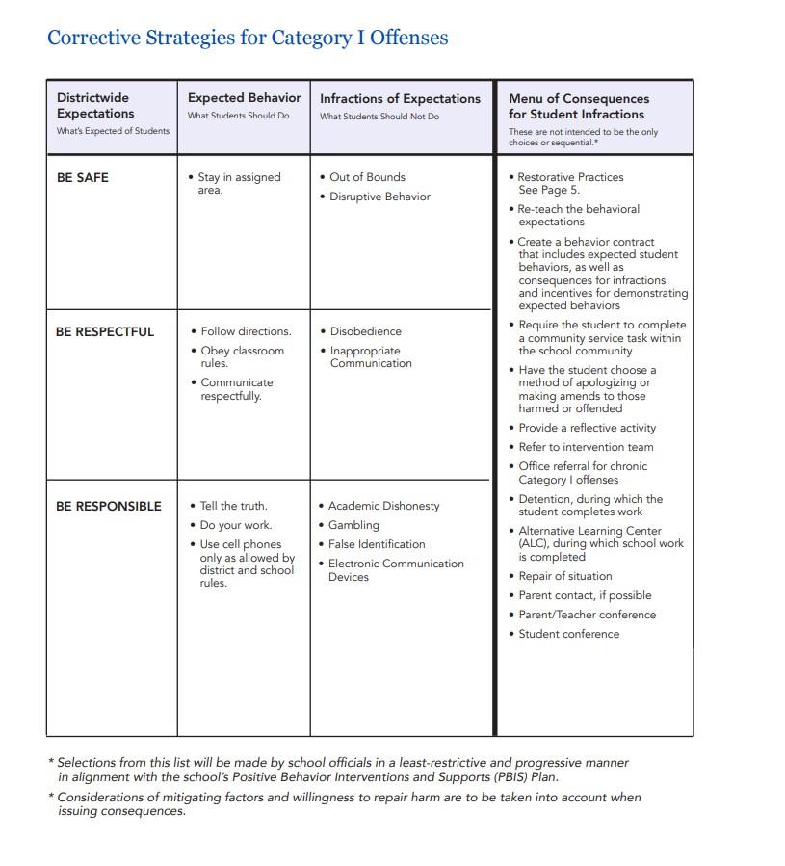
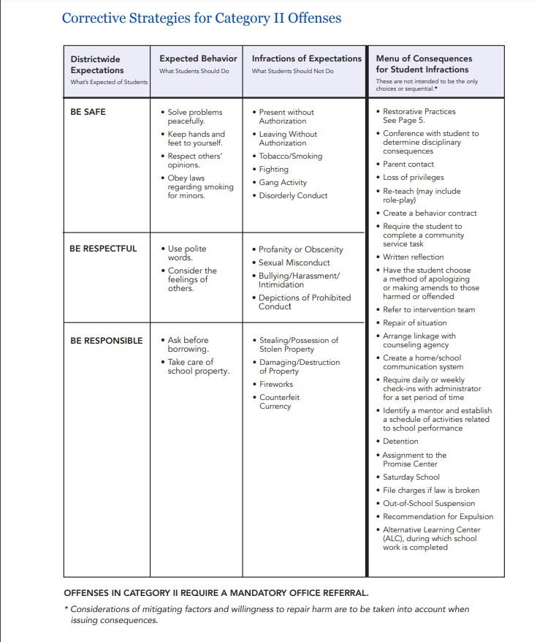

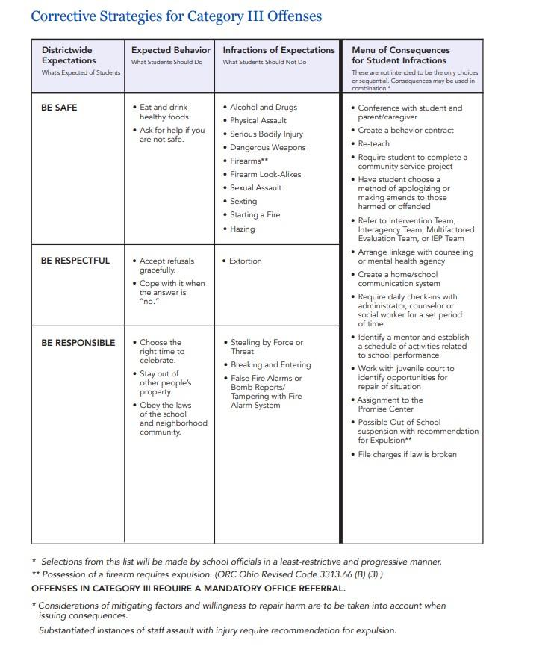

BULLYING AND HARASSMENT Bullying Board Policy 5517.01
Bullying And Other Forms Of Aggressive Behavior
SUMMARY
The following policy shall be in accordance with applicable State and federal laws.
Cincinnati Public Schools has a very strict policy against bullying and other forms of aggressive behavior. Please review the policy which is also included in your opening school year information, with your child.

- Bullying/Harassment Behaviors: Cincinnati Public Schools strives to maintain safe, supportive learning and working environments. In support of this effort, PRM prohibits bullying, harassment and intimidation by any student or staff. Bullying, harassment or intimidation is defined as:

“Any intentionally written, electronic, verbal, graphic, or physical act that a student or group of students exhibit more than once, toward another particular student(s), and the behavior both causes mental or physical harm to the other student(s); and, is sufficiently severe, persistent, or pervasive that it creates an intimidating, threatening, or abusive educational environment for the other student(s).”

- To maintain an environment conducive to learning and protecting the health and safety of the school community, administration will investigate incidents of reported bullying and other aggressive behavior.

- All school staff that sees acts of harassment, intimidation, or bullying shall promptly notify the building Principal of the event(s) and submit a Bullying Complaint Form. A complaint should be specific including: identification of the person(s) participating in the bullying as well as the person(s) being bullied, names of witnesses, location, date and time, and the bullying behaviors observed.

- Teachers and other school staff who receive student or parent reports of suspected harassment, intimidation, or bullying shall promptly notify the Principal. Students who make complaints may request that their names be maintained in confidence by employees. Students deliberately making false reports of harassment, intimidation, or bullying is strictly prohibited and shall be disciplined.

- Under the direction of the building Principal, all complaints shall be investigated promptly. In evaluating conduct for harassment, intimidation, or bullying, special attention should be directed to the words chosen and/or the actions taken, whether such conduct occurred in front of others or was communicated to others, how the harasser interacted with the person being harassed, and the motivation, either admitted or appropriately inferred.

- A written report of the investigation shall be prepared by an Administrator when the investigation is complete. Such a report shall include findings of fact, a determination of whether acts of harassment, intimidation, or bullying were verified, and a recommendation for intervention, including disciplinary action. Parents or guardians of any student involved are to be notified, and to the extent permitted by the “Family Educational Rights and Privacy Act of 1974,” 88 Stat. 571, 20 U.S.C. 1232q, as amended, has access to any written reports pertaining to the prohibited incident.

- Verified acts of harassment, intimidation, or bullying shall result in intervention by the building Principal to ensure that the prohibition against harassment, intimidation or bullying behavior is enforced and prohibited behavior ceases. When verified acts of harassment, intimidation or bullying are identified early and/or when verified acts do not require a disciplinary response, students should be counseled. A suspension to A2S/A2E may be imposed only after informing the student of the reasons for the proposed suspension and giving the individual an opportunity to respond. When acts of harassment, intimidation and bullying are verified and a disciplinary response is warranted, students are subject to the disciplinary consequences as stated in the District’s Code of Conduct.

- Complaints received by students who request anonymity shall be reviewed and reasonable action will be taken to address the conduct. When discipline is warranted, action may be taken that (1) does not disclose the source of the complaint, and (2) is consistent with the District’s Code of Conduct

SUICIDE PREVENTION
Students face a wide range of issues and concerns that can have a substantial impact on their ability to learn and on their engagement with school. Perhaps the most severe issue faced by students is that of depression accompanied by suicidal ideation. The school district takes these mental health issues seriously. To further this objective, the Superintendent shall develop and implement administrative guidelines whereby members of the professional staff understand how to use an intervention procedure.
ORC.3313.666
Approved: 04-09-12
10-10-11
Revised: 11-18-13

PRM Caregiver/Student/School Agreement
General expectations for parent, student, and staff behavior are outlined in the PRM Parent/Student/School Agreement. Caregivers, please read and discuss the agreement with your children. After doing so, please sign the agreement along with your child, and return the signature page to your child’s homeroom teacher by September 1st. We also ask that you talk with your children about the importance of demonstrating respectful behavior and maintaining a positive attitude while at school. In a Montessori classroom, it is necessary for children to develop self-discipline in order to further their learning.

Please sign and return the Parent/Student/Teacher Agreement to school by the closest school day to September 1st.

